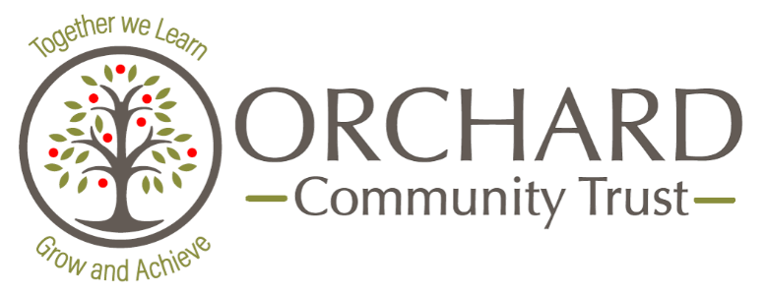

‘Committed to improving the life chances of all children, wherever
they may be’

GENDER PAY GAP REPORT: Snapshot Date 31/03/2023
- Percentage of men and women in each hourly pay quarter:
Quartile | % Female | % Male
Lower | 92.6 | 7.4
Lower middle | 94.2 | 5.8
Upper middle | 90.8 | 9.1
Upper | 81.7 | 18.3

- The mean (average) gender pay gap in hourly pay as a percentage is 27.29%

- The median gender pay gap in hourly pay as a percentage is 40.79%

- 0% of men and 0% of women receive bonus pay

- Mean (average) gender pay gap using bonus pay is 0%

- Median gender pay gap using bonus pay is 0%
There were 483 total employees during the reported period. 434 are female and 49 are male. 89.9% of the workforce are female and 10.1% are male. The majority of the support staff roles are undertaken by females, with salaries that fall in the lower and lower middle quartiles.
The Trust has a clear set of job descriptions which go through an evaluation process to determine pay range for each post, ensuring the correct pay is awarded for the role the employee undertakes. This process is applied consistently across all schools and the central team.
Orchard Community Trust is an equal opportunities employer. We will always choose the right person for the role and we will never refuse a candidate based on their gender.
As Accounting Officer for the Trust, I confirm the gender pay reporting data is accurate.

Mr Rob Johnstone
Senior Executive Leader

